Character lists:
Theseus (Depressed John Goodman): A man who was never supposed to sit still, but has been doing so for far too long. In his heart, longs for his glory days of adventure. In a rather stilted relationship with Hippolyta, with both of them just as trapped as the other. Bored, standoffish, like a disappointed middle manager. John Goodman is present in many of the hearts and minds of the audience, be it in children’s films or otherwise, so seeing him in this role can be both satisfying or heartbreaking.
Oberon (Orlando): Dynamic, virile, and motivated. Theseus in his prime, and boy does he know it. Freewheeling, philandering, monster-fighting, all are daily pastimes of his, leading to a sort of manic Ennui. In his heart, he longs for a way to live on beyond himself, which is where the Changeling comes in. Orlando’s Orlando, what more could be said?
Changeling (Millie Bobby Brown

): Just sort of stands around and looks cute. Essentially, a cameo role. MBB was chosen due to her ‘star power’, plus, a good way to connect to “stranger things”.
Hippolyta (Margret Thatcher)
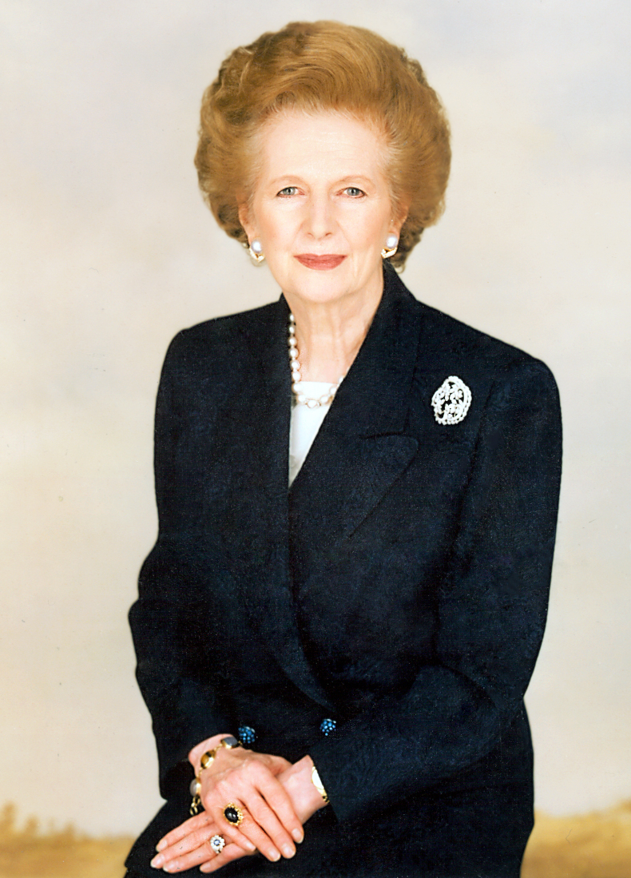): A woman forced into several hard decisions, Hyppolyta wears her years on her sleeve. In her heart, she wants to lead again, having taken to it well on the battlefield. Had an awkward relationship with Theseus, still does, in some ways. As one of the more harried MPs, Thatcher was a natural choice.
Titania (Boudicca):
A ruler, first and foremost. Governs her piece of the Dreamscape with power and certainty. In her heart, wants to raise a legacy, which is where the Changeling comes in. Drawing a historical British parallel seemed like the best option for this dreamlike depiction.

Lysander (John Wilkes Booth)

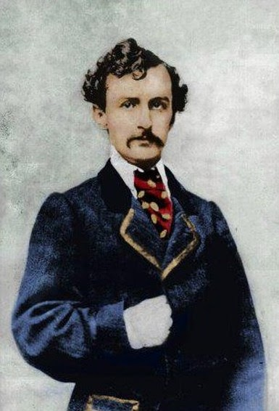

: In a word, a gentleman. An experienced Shakespearean actor, handsome too. Ready to fight and die for that which he believes in, but wrapped in an old-time courtesy. For these reasons, I choose booth as Lysander. He would really bring the ‘star power’ this performance needs.
Demetrius (Leon Czolgosz)

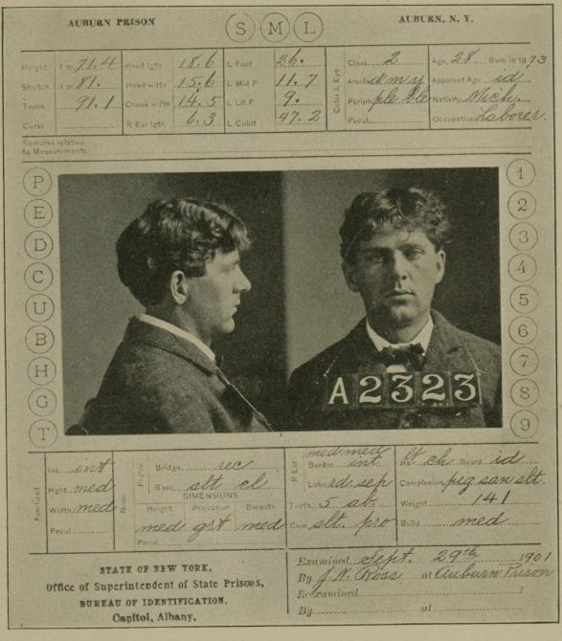

: Everything that Lysander is not. Crude, brash, and stunted, with definite control issues. One should feel a looming, creeping unease whenever they see him, but moreso rooted in issues and causes that, as represented, are all too real. A certain degree of this is imposed through issues with his father, Czolgosz is, in summary, a thoroughly disagreeable man. My main reason for choosing Czolgosz as Demetrius is the continual second fiddle to the more renowned, romanticized Booth.
Hermia (Nichelle Nichols)

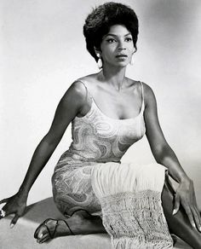

): Short, dark, and fierce. Hermia plays a more significant role in our adaptation, arguably being the main protagonist of it. The first of the lovers to enter the dreamscape, Hermia will serve as the audience’s center to reality. Nichols was chosen for her timeless roles, and the sense of 60’s nostalgia.
Helena (Helen of Troy): Tall, blond, and angsty. Mostly unchanged from her adaptation, but unique in her appearance in the dreamscape. There’s no guarantee that the Helena we witness is the same woman in the waking world, or rather existing as a set of delusional fragments, so lost in her obsession for Demetrius. For the casting, we were anticipating a more classical figure.
Puck (1964Dick van Dyke)

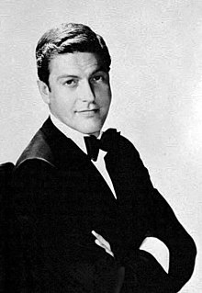

: You know him, you love him. The god/ collated dreams of Athens, he could rule the Dreamscape if he wanted to, but where’s the fun in that? Bette to help others to find themselves. Dick Van Dyke has the energy and presence for the role, like a classier Jim Carey.
Peter Quince (Joseph Goebbels)

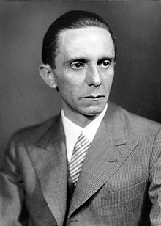

: A man who has certain expectations of Pyramus and Thisbe, and only lives on to see them let down. The Mechanicals ‘get’ certain things about his vision, but it just keeps going wrong. Ultimately, Quince will never have the dreams he pushed fulfilled. As a result, he bounces from euphoric to crestfallen, in a very short period of time. Goebbels was chosen to juxtapose him against the leading Communist figures present within the mechanicals.

Nick Bottom (1915 exile Josef Stalin
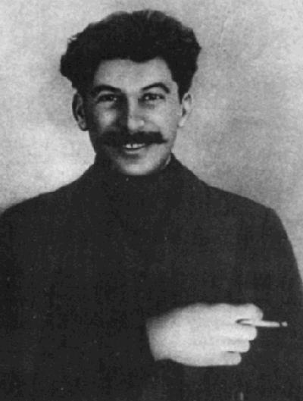):
Our ‘main man’ of the Mechanicals, he’s mostly the reason the group’s together. Fiery, charismatic, and , quite frankly, the best actor of them. He’s got dreams of fame and stardom, and he’ll do what he must to achieve them. Stalin started off the whole Communist boat ride, so it makes sense for him to be the leading figure.

Francis Flute( 1840s Fredric Engels)

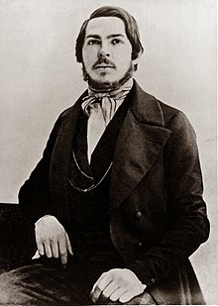

: One of the brains behind the mechanicals, Flute has a mind of his own, but its often drowned out by the grandstanding Bottom or the machinations of Peter Quince. In his heart, he wants to be the noble knight that leads the way, but he’s never been granted that chance. Poor Engels always got sidelined, so perhaps a theatrical role will let him exhibit such sidelining once again.
Starveling(Kim-Jong-Il)
Older gentleman who’s not the best at acting, but still wants to get at it anyways. Mostly so his kids can see how he does. Treated as ‘team dad’ by most of the Mechanicals.
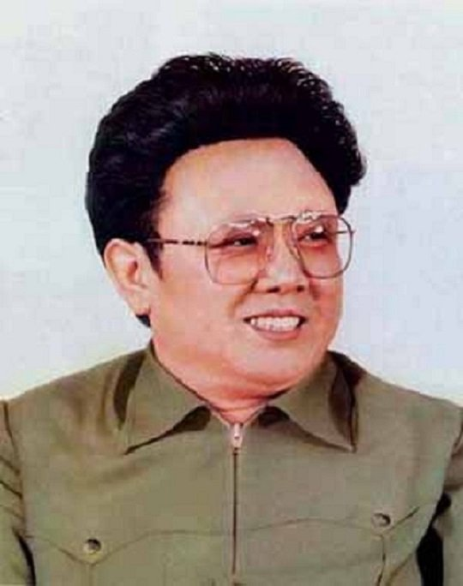

:
Snout ( Mikhal Gorbachev)
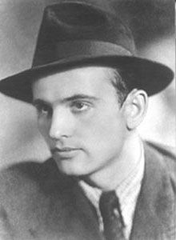

: Looks good, but kind of flat and weak. The mechanicals know it, he knows it in himself, but wants to deny it. Honestly, he wants to be more assertive, but he questions why it needs to be. See: Gorbachev.

Snug (Fidel Castro, as embodied in this moment:
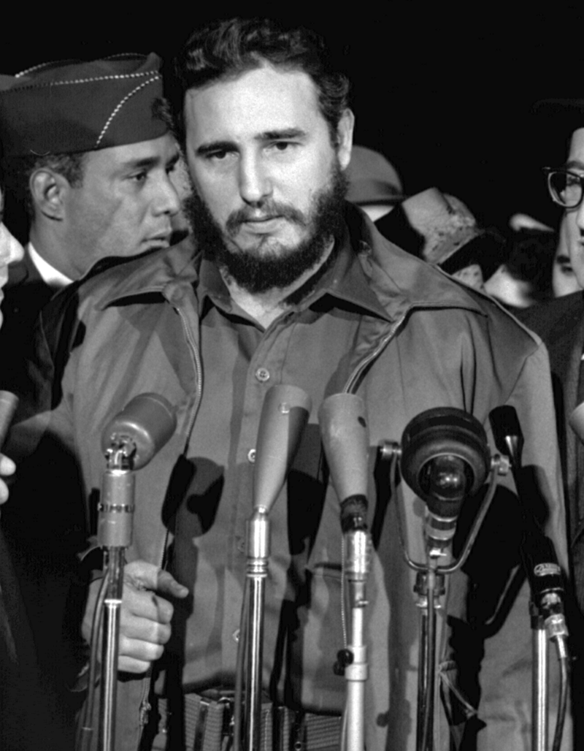): Shy, awkward, and still coming into his own. The ‘new guy’ of the mechanicals, he contains a hidden, introspective depth to him. Ultimately, he wants to prove himself to the rest, and, at the climax of the play, he does. Castro was chosen, in part for his expression in this picture, but also his role in the Cuban revolution, as a fledgling autocrat of a troubled nation.
Philostrate ( Quentin Tarantino)

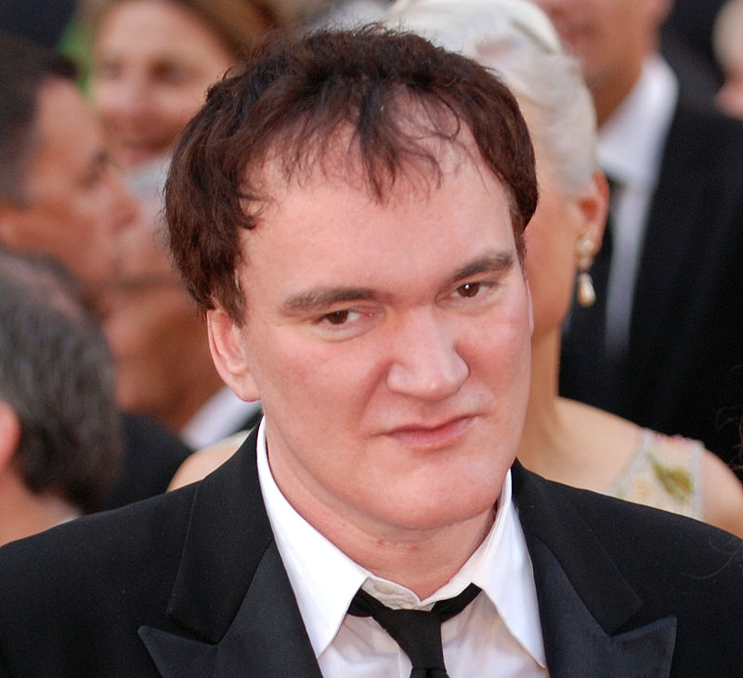

: An ideal cameo, given his minor role in the play. See Philostrate, See Tarantino.

Mote: A Swarm of bugs.
Mustardseed: Bee- plant hybrid, with four golden leathery wings, and an insectoid face.
Cobweb: Shambling wad of webs wrapped around a dead body. In mannerisms, most like Big Bird in anything else.
Pease blossom: Multi-eyed pod-person/aphid hybrid, with occasional eyes `leaking out of the pod.

